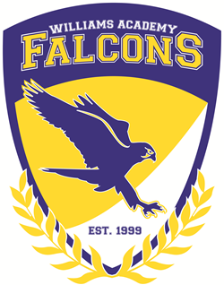
Agenda
Board of Directors’ Meeting
Marjorie Williams Academy
April 30, 2021
Electronic

Call to Order: For Action Items:
- None
For Information Items:
- Review income expenses to date –.no questions or concerns
- Upcoming Events – graduation video and small ceremony planned
- Enrollment – 115 students – increase in enrollment as expected due to increase in DSS referrals
- Public Input - Adjourn – Meeting was adjourned and agreed by all

Mission Statement: The mission of Marjorie Williams Academy is to offer a stable, emotionally supportive, educational environment for children with a goal of empowering each child to achieve his or her real academic and social potential.

Vision: The vision of Marjorie Williams Academy is to become a model school for academic achievement.

BELIEFS:
• Academic growth of all students is the priority of the school
• Students learn best in an environment that promotes student active engagement using a variety of strategies that accommodate diverse learning styles and intellectual levels
• Healthy, safe, orderly and caring environments promote student learning
• Parent, community, and school collaboration are vital to the success of school’s mission
• Students will develop a respect and responsibility for community through active participation in service oriented opportunities
• Opportunities and exposure to experiences beyond the school will influence students towards setting positive goals for future
• On-going and meaningful professional development is crucial to teacher growth and ability to provide quality instruction.

