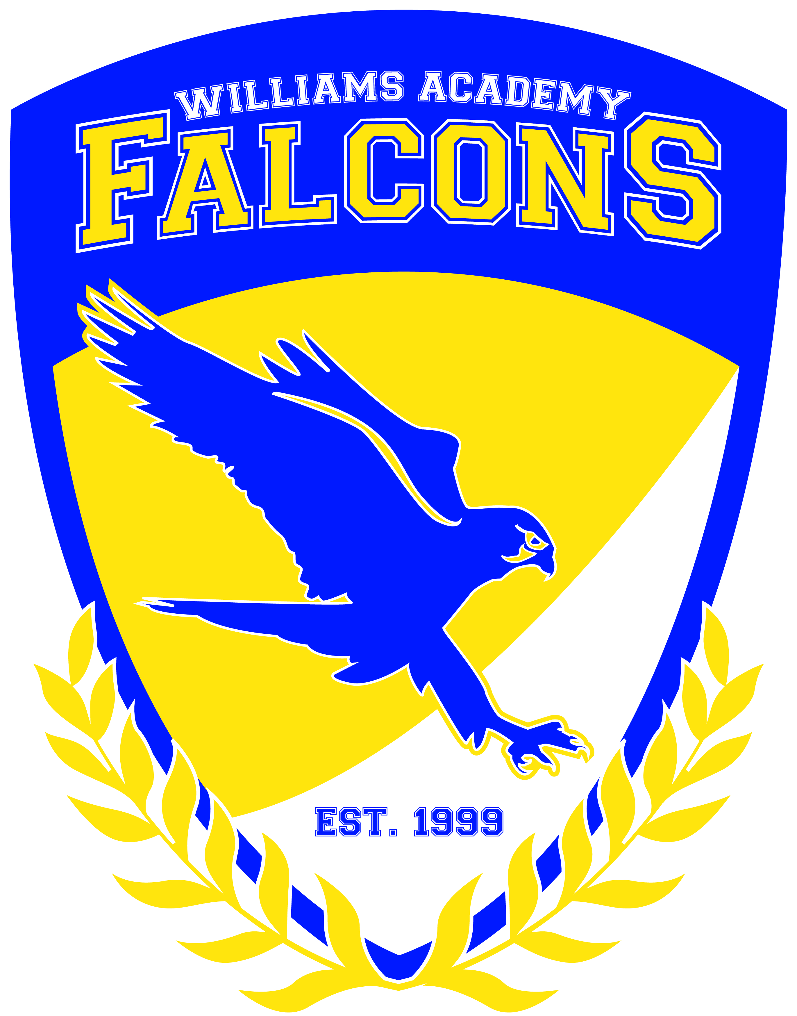
Agenda
Board of Directors’ Meeting
Duke Mansion
400 Hermitage Rd, Charlotte, NC 28207
February 1, 2019
9:30 a.m. – 11:45 a.m.

Call to Order: Royster called the meeting to order at 9:42 – motioned by Barnhardt; seconded by Beck
Present: Royster, Williams, Oates, Richardson, Barnhardt, Beck, Burnett
Absent: Guy
Others: Austin
For Action Items:
- CSAB Presentation
  - Action to pursue alternative school status
  - Austin explained the CSAB reasoning to change to alternative schools status was to use a different calculation for grading which will artificially increase the school grade. Austin explained the devastating repercussions of changing the status to Alternative school status. Austin explained the legislative scoring process of an 80/20 proficiency/growth which puts the low income Title 1 schools at a disadvantage to the affluent proficiency school. Austin explained how proficiency is performance and growth is education and how the calculation places a higher importance of performance over education. Austin also pointed out that if the calculation was 50/50 the Academy would be in a C range. The board rejected the alternative school status – Barnhardt motioned; Richardson seconded; all in favor
- Approve May/June board meeting date and time – meeting date: May 31, 2019 – 3:00-4:00 Williams motioned; Oates seconded; all approved

For Information Items:
- Review income expenses to date - questions about the decrease in enrollment due to the Family First Act and how that will affect the budget. Austin explained that the decrease in enrollment will affect next year’s budget and plans are in place to account for the drop in enrollment. No raise will be given but a supplement will be provided.
- Field Trips Community Involvement – Austin explained that field trips are funded but boxtops
  - Altapass Apple Orchard – K-1st Grade
  - Butterfly Farm – K-1st Grade
  - Valley Crucis Pumpkin Farm – K-1st Grade
  - Sugar Plum Farms – K-1st Grade
  - Harvest Pumpkin Farm – 2nd-3rd Grade
  - Camp Harrison – Overnight – 6th – 8th Grade
  - Avery County Fair – K-8th Grade
  - Overmountain Victory Celebration – 2nd - 5th Grade
  - Healthy Halloween – K-2nd graders
  - Carolina’s Aviation Museum – High School Science of Flight Class

- Community Service Projects
  - Family sponsorship: Middle school raised $800.00 through donations and selling handmade ornaments to sponsor a family of 5 with Christmas presents and food.
- Guest speakers
    - Fred Frawley - storyteller
- Student Data Updates
- EOC semester scores
- ACT – Feb. 20th
- ACT/SAT Data Report –
ACT:
Average Composite Score
(2014) - 18.1
(2015) - 18.8 Growth of 3.9%
(2016) – 19.6 Growth of 7.1%
(2017) – 14.6 Growth of -26.6%
(2018) - 16.1 Growth of 9.80%
SAT:
Average Score
(2014) - 1315
(2015) - 1257 Growth of -4.4%
(2016) – 1231 Growth of -2.1%
(2017) – N/A
(2018) – N/A

- Seniors – Post Grad Intent:
Last, First |  | Applications Submitted | Acceptance Letters | Scholorship Opportunities | First Choice | Intended Major | Notes
Davis, Dezera Dashae |  | Johnson-Wales, Brevard College, Mayland, A-B Tech | Mayland, Brevard College | ? | Mayland | Culinary Arts
Dula, Tyler James |  | ASU, ETSU, WCU, ECU | ETSU |  | ASU, ETSU | History Education
Geouge, Dalton Michael |  | Mayland | Mayland | 2, will find names | VMI | Astronomy (associates in science) | Prep for first day of college. Plans to go to school first, then join military.
Lee, N' Dia Dashae |  | A-B Tech, Mayland, Forsyth Tech, Paul Mitchell | Mayland | DAR scholarship | A-B Tech | Cosmetology | Concerned that no answer has been given form the community colleges to date.
Moore, Shyanne Evelyn Debra |  | Mars Hill, Mayland, A-B Tech, Forsyth Tech. | Mars Hill, Mayland | DAR scholarship | A-B Tech | Cosmetology | Plans to apply to Paul Mitchell also. Verify FAFSA has been completed.
Sellers, Sage Haley
Simpson, Hai'Lee Deserae |  | Winston Salem State, Gardner-Webb, Isothermal CC | Isothermal CC |  | Gardner-Webb | Undecided | FAFSA completion, Ms. Todd has assisted, however not currently complete.
Waddell, Cassidee Grayce |  | Mitchell CC, Mayland | Mayland |  | Mitchell CC | Paramedic

- Upcoming Events
Feb. 5 - Math Foundations Training
Feb. 12 - Math Foundations Training
Feb. 15 - OWD
Feb. 19 - Math Foundations Training
Feb. 26 - Math Foundations Training
March 11 - OWD
March 12 - End of 9 Week Grading Period
March 22 - Academic Achievement Recognition Program
April 12 - ED (12:45) ½ RWD
April 13 - Prom (7-10)
April 18 - ED (11:15)
April 19 - OWD
April 22-26 - Spring Break
May 15-24, 28-29 - EOG/EOC Testing
May 27 - Memorial Day Holiday
May 29 - Awards Day ED (11:15) Awards time 8:30
May 30-31 - RWD
June 1 - Graduation
- Enrollment – 105 students – drop in enrollment is due to the Family First Act
- Public Input – none
- Williams motioned to dismiss at 11:15; Barnhardt seconded; all agreed

Upcoming Board Meeting: TBD

- Charter School Information:
Charter School Homepage http://www.ncpublicschools.org/charterschools/
Governance Board Training Opportunities http://www.ncpublicschools.org/charterschools/training/governance/
NCEES Training for Principal evaluations

Mission Statement: The mission of Williams Academy is to offer a stable, emotionally supportive, educational environment for children with a goal of empowering each child to achieve his or her real academic and social potential.

Vision: The vision of Williams Academy is to become a model school for academic achievement.

BELIEFS:
- Academic growth of all students is the priority of the school
- Students learn best in an environment that promotes student active engagement using a variety of strategies that accommodate diverse learning styles and intellectual levels
- Healthy, safe, orderly and caring environments promote student learning
- Parent, community, and school collaboration are vital to the success of school’s mission
- Students will develop a respect and responsibility for community through active participation in service oriented opportunities
- Opportunities and exposure to experiences beyond the school will influence students towards setting positive goals for future
- On-going and meaningful professional development is crucial to teacher growth and ability
to provide quality instruction.

